SPRINT-4.

| Date | 14 November 2022. |
| --- | --- |
| TEAM ID | PNT2022TMID23457. |
| Project Name | IoT Based smart crop Protection system for agriculture. |
| Maximum mark | 20 marks. |

STEP 1: MIT APP inventor to design the APP.

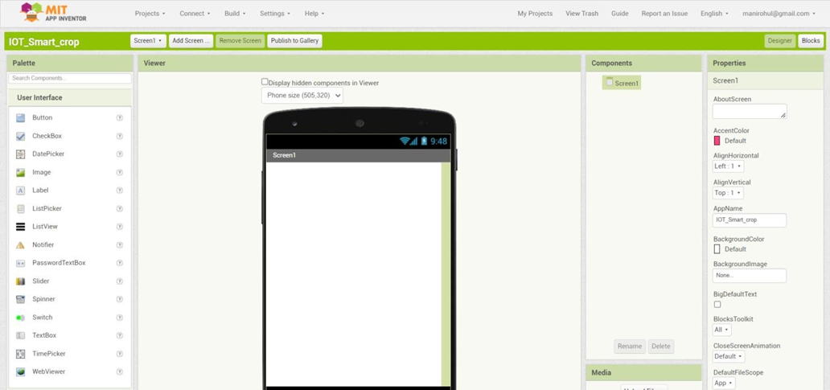

STEP 2: Customize the App interface to Display the Values.

